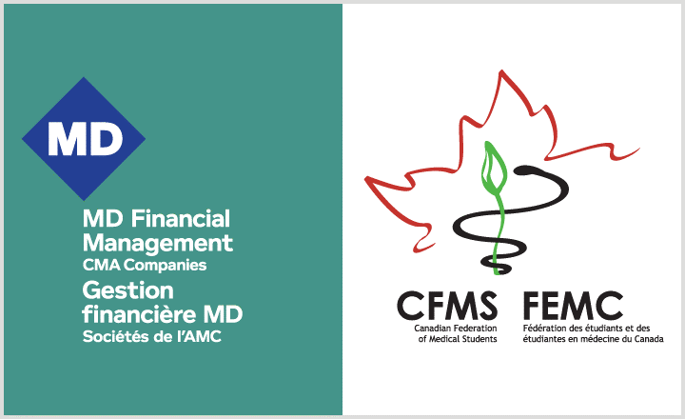
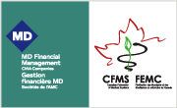
CFMS GENERAL MEETING TRAVEL FUNDING REQUEST

Promoting engagement of medical students within the CFMS

CFMS SGM: April 27-28 2018 • Halifax, NS

The Canadian Federation of Medical Students is the national voice of Canadian Medical Students. We connect, support and represent our membership as they learn to serve patients and society.

The CFMS, in partnership with MD Financial Management, has set aside funds for the 2017-2018 academic year to provide financial assistance for CFMS member medical students who wish to attend our Spring General Meeting, held April 27-28, 2018 in Halifax, NS. All funding is subject to our CFMS Travel Policy, which can be viewed online at CFMS Travel Policy.

Applicants who are selected to receive a travel award are reimbursed for their cost of travel to the meeting, in accordance with the CFMS Travel Policy. The registration fee is also waived for travel award recipients, and accommodation is provided in a hotel room shared with 1 other travel award recipient. Accommodations for recipients are arranged directly by the CFMS and any other accommodation (i.e. in another hotel room) cannot be reimbursed. Finally, a 50$ registration fee for the Canadian Conference on Medical Education (CCME), held concurrently with SGM will be reimbursed to all travel award winners.

This initiative supports non-elected members to attend CFMS meetings with the goals of fostering greater member awareness of CFMS structure and function, promoting increased interest in the CFMS and facilitating increased participation in CFMS activities.

The application process is competitive and the CFMS routinely receives a far greater number of applications than the number of funded spots available. Applicants are selected based solely on the merits of their written application as judged by a selection committee.

Please speak with your school’s CFMS Representative for more information about these meetings and visit www.cfms.org to find out more about the CFMS.

Eligibility:

- Applicant must be a medical student at a CFMS Member School in Canada, or an individual member of the CFMS (studying at a Canadian Medical School in Quebec).
- Applicant must not be the current President of their Medical Student Society, CFMS Representative (Jr. or Sr.), or a Global Health Liaison. Likewise, CFMS Officers and Representatives to External Organizations who are separately funded are not eligible.
- Medical students who have previously been awarded a CFMS General Meeting Travel Award are not eligible to apply for a second award.
- Travel award recipients must be present for the start of the meeting (8:30am on Friday, April 27th, 2018) and must be present for the entire length of the meeting in order to be eligible for funding. Accommodations for travel award recipients will be provided for the nights of Thursday April 26, Friday April 27, and Saturday April 28 only.
- Travel award recipients will be required, after the meeting, to submit one paragraph outlining their experience at the meeting. Reimbursement for travel will only be issued once this has been received by the CFMS.

Application instructions – PLEASE READ CAREFULLY:

- Applicants are requested to complete the Funding Request Form, including the table and the maximum 300 word paragraph (see next page).
- The file should be saved as LASTNAME_FIRSTNAME_SGM2018 in Word document format (.doc or .docx) only. Other formats will not be accepted.
- Completed application forms must be submitted to Victoria Januszkiewicz, Atlantic Regional Representative, by email to: atlantic@cfms.org no later than 11:59pm EST MARCH 2nd, 2018. Applications received after the deadline will not be considered.
- Once submitted, applicants will receive (within 72h) an email confirmation that the application has been received.
- Applications will be blinded and evaluated by members of the selection committee.
- Applicants will be notified of funding decisions by March 16th, 2018.
- Applicants are kindly requested to refrain from registering for the CFMS SGM prior to receiving a funding decision; travel award recipients will be able to register for the meeting when they are notified of the funding decisions.
- Travel award recipients will be sent detailed instructions requesting travel confirmation. Travel must be booked to allow the recipient to attend the entire meeting.
- Travel award recipients will be reimbursed for their travel, in accordance with the CFMS Travel Policy, after they have submitted both an expense report and a paragraph summarizing their experience at the meeting. Cheques are usually issued within 2 weeks of receipt of these documents.
- Travel award recipients must submit their expense report and summary paragraph by May 30th, 2018 at the latest in order to be reimbursed.
CFMS Meeting Travel Funding Application

First Name
Last Name
Gender
Medical School
Expected Year of Graduation
Home Address: Street address + apt. #
City, Province
Postal Code
Phone Number
Email Address
Have you attended a CFMS general meeting (AGM or SGM) or National Day of Action in the past? If so, which one(s)?
Do you currently sit on or chair a CFMS committee, or have you done so in the past? If so, which one(s)?
Amount of funding requested for travel (approximate cost of round-trip travel to the meeting, e.g. 60$ for taxis and $940 for round trip airfare = $1000 total funding request)

In the space below, please write a paragraph (maximum of 300 words) outlining why you should be selected to attend a CFMS general meeting. Applications that exceed a total of 300 words will not be considered. Applications may extend onto the following page.

Note that applications will be evaluated on the following criteria:
- How will attendance at this meeting benefit the applicant and his/her medical school (60%)
- How will attendance at this meeting benefit the CFMS (30%)
- Communication skills (10%)

